Estimating functional discriminability across the brain using large-scale classification
Introduction
Mapping cognitive functions to brain anatomy is central to understanding the functional organization of the human brain. Functional magnetic resonance imaging (fMRI) studies have had some success in discovering brain areas that specialize in certain processes – such as the fusiform face area for face perception. However, the utility of individual studies in this endeavor is inherently limited by the study’s scope, and noise in the measurement. Large-scale databases of fMRI studies, such as Neurosynth, overcome some of these limitations by aggregating over thousands of studies to robustly identify which functions most strongly associate with activity across the brain. These databases have been used describe the function in specific subdivision of regions, such as the insula (Chang et al.,) as well as across the whole brain (Anderson et al., ).
Existing meta-analyses are useful for labeling regions with their most associated functions, but they don’t give us a measure of how useful these labels are for predicting brain activity. Beyond brain mapping, cognitive neuroscience aims to build models of how cognitive states relate to brain activity patterns; an idealized model should be able to predict perfectly which regions a task would activate, given the underlying processes of that task. While we’re nowhere near this idealized model, we already make predictions – for example, many would predict a fearful face would almost certainly activate the amygdala. However, for most regions, it’s unclear how robust the relationships between our existing cognitive ontology and activity is. This information is crucial for evaluation the state of our field, and understanding the kinds of relationships that existing between cognition and anatomy across the brain. It is likely that activity in regions with specific, circumscribed functions – such as sensory cortices – will be easier to than in regions with more abstract, domain-general functions.

In the present study, we used multivariate machine-learning classification to develop prediction based metrics of function to brain anatomy mappings. For every region of the brain, we trained a linear classifier
to discriminate studies that activated that region from those that did not, using the semantic content of the studies as learning features. We tested the classifier’s ability to determine if unseen studies activated a region, terming performance ‘discriminability’; this novel metric is indicative of how well characterized activity in a region is by the existing cognitive ontology. Next, we determined how useful different cognitive functions were in predicting brain activity across the brain by examining the weights of the fitted classifiers. Finally, we determined the plurality of function exhibited in each region, as well as the utility of employing a multivariate approach, by analyzing how many cognitive functions were necessary to predict activity for each region.

Methods

We analyzed the Neurosynth database (neurosynth.org), a repository of 9,721 fMRI studies and over 700,000 activations. Each observation in the database contains the peak activations for all contrasts reported in a study’s table as well as the frequency of all of the words in the body of the text. Although meta-analyses of cognitively relevant words yield activation maps consistent with neuroscientific knowledge, there is a high amount of redundancy between words (e.g. ‘memory’ and ‘episodic’) and potential ambiguity as to the meaning of an individual word out of context. Thus, we employed a set of 80 topics derived using latent dirichlet allocation topic-modeling (see Poldrack et al., 2012). The resulting topics reflect the underlying semantic structure of neuroimaging studies while simultaneously yielding more robust meta-analytic maps for individual features. Each study in the database has a load weight to each topic reflecting the semantics of the text.
To estimate discriminability for each region, we trained a classifier to discriminate between studies that activated that region versus studies that did not. We defined ‘active’ studies as those that activated a minimum number of voxels in the ROI (ranging from 10 to 500 depending on resolution of parcellation, see supplemental materials) and ‘inactive’ as those that did not activate any voxels. Active studies were labeled as the positive class (coded as 1) and inactive studies were labeled as the negative class (coded as 0). Next, we trained a regularized linear regression with an L2-penalty, or ridge regression, to predict the label of each study in a region’s set. Ridge regression is well suited for classification with many co-linear features: large coefficients are penalized, resulting in a dense yet stable solution with class-leading predictive performance. We treated the regression as a binary classification problem by converting predictions for unseen data above 0.5 to 1 (‘positive’) and below 0.5 to 0 (‘negative’). To avoid overfitting, we tested our models using 4-fold cross validation. Each model was on trained 3/4ths of the data and asked to predict the class of the remaining 1/4th, circulating over the dataset such that the model was trained and tested on the entire dataset. The mean score across the four folds was used as the final measure of discriminability for each region. We scored the classifiers by taking area under the curve of the receiver operating characteristic (auc-roc). This common classification metric, ranging from 0.5 for chance to 1 for flawless predictions, is not biased by the balance of sample sizes between the two classes, which can vary between regions. (CITE) Finally, for each region, we extracted the regression weights for each topic (‘topic weights’); positive weights indicate the discussion of that topic in a study predict activity in the region, while negative weights indicate the topic is anti-predictive of activity.
We estimated discriminability for four parcellations of the brain that varied in resolution. We defined regions by clustering voxels together with similar coactivation profiles across studies in the database. We used Ward clustering to group voxels into 10, 20, 30, 40, and 50 clusters. Consistent with the topology of the human brain, clusters consisted of contiguous voxels or bilateral structures.
For each region we calculated how many features are necessary for successful classification. First, we took the absolute value of the topic weights for every region, to determine which regions were most useful in classification. Next, we reran the classification 80 times, starting with only the most useful feature as data, and progressively adding more features ordered by their absolute topic weight.
Threshold selection. We selected activation thresholds – the minimum number of voxels a study had to activate in a region to be included in classification – empirically in order to maximize discriminability. We tested a wide range of activation thresholds (10 to 500 voxels) on the five parcellation maps of varying resolution (10-50 regions). There were not enough studies for classification using high thresholds on high resolution maps, so there are no results for those combinations. The optimal threshold varied as a function of the resolution of the parcellation (Figure S1). Discriminability peaked using higher thresholds for low resolution parcellations and using lower thresholds for high resolution parcellations. For high resolution parcellations (e.g. 50 regions), there was a positive correlation between the number of studies used for classification in a region and discriminability (r = 0.59), suggesting low amounts of data was responsible for worse performance at higher thresholds. For low resolution parcellations (e.g. 10 regions), the reverse was true – regions with more studies were classified more poorly (r = -0.84) – suggesting that at low thresholds large regions were characterized too heterogeneously, resulting in poor discriminability. For the main results, we focused on the thresholds that resulted in maximum discriminability for each parcellation resolution.
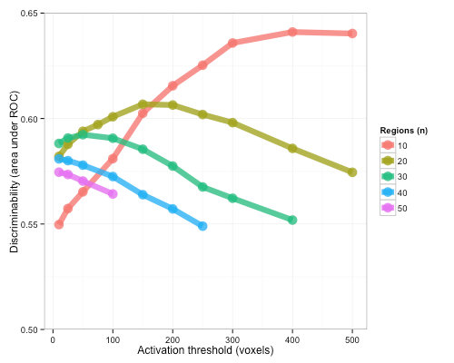
Figure S1. Discriminability (area under ROC) peaked at different activation thresholds (number of voxels activated by a study in a region) depending on the resolution of the parcellation used (number of regions).

Results

On average, we were able to discriminate studies that activate a region from those that do not above chance (mean auc-roc = 0.59). Discriminability varied as a function of the resolution of the parcellation used: discriminability peaked using coarse regions and decreased as the resolution increased (Figure 1). Lower discriminability for finer grained regions was not due to a dearth of data. In fact, at the respective
optimal threshold, the number of studies activating a region peaked using 40 regions and was lowest using 10 regions (Table 1). Henceforth, we focus on the results from 30 regions, as they strike a balance between anatomical specificity and accurate discriminability.
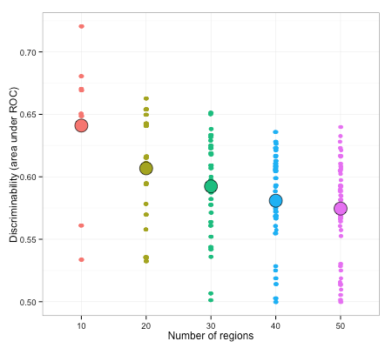

Figure 1. Discriminability as a function of the number of parcels. Mean discriminability for each parcellation is shown by the large points and the discriminability for individual regions is shown using smaller points. Peak discriminability decreased as a function of the number of regions.
Regions in parcellation (n) | Threshold  (voxels) | Discriminability  (roc-auc) | Active studies | Voxels
10 | 400 | 0.64 (0.53) | 2460 (1323) | 22845 (23561)
20 | 150 | 0.61 (0.04) | 2954 (1223) | 11422 (11095)
30 | 50 | 0.59 (0.04) | 3724 (1267) | 7515 (9205)
40 | 10 | 0.58 (0.35) | 4145 (1308) | 5711 (7728)
50 | 10 | 0.57 (0.04) | 3761 (1327) | 4569 (6234)

Table 1. Descriptive statistics on the optimal threshold used, and mean discriminability, number of activate studies, and number of voxels for the five parcellations used. Standard deviation in parentheses.

Regional discriminability showed wide variability across regions, ranging from near chance performance, for motor cortex, to robust discrimination, for the superior parietal lobule (Figure 2, auc-roc range: 0.51 - 0.65). Discriminability was slightly lower for larger regions (r = -0.29, p = 0.12), but this effect is not significant, allowing for comparison across parcels of different size (see supplemental materials for discussion of relationship between threshold selection and voxel size discriminability).
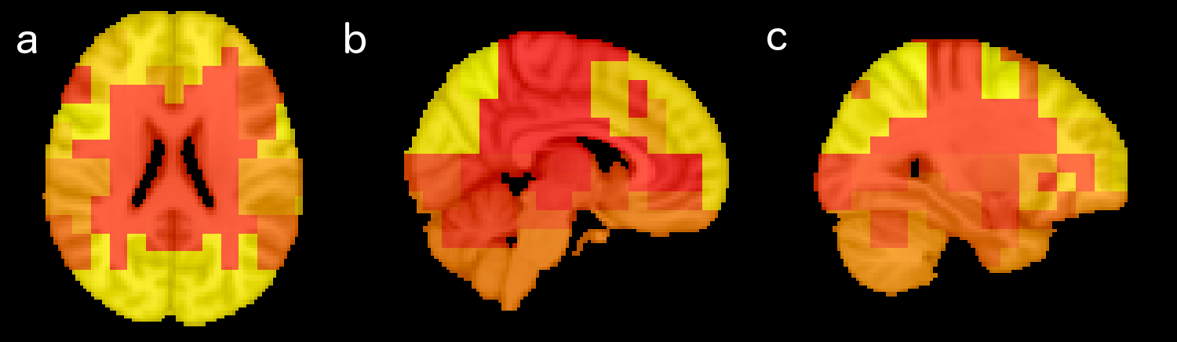
Figure 2 Discriminability varies across the brain. Lighter colors represent higher discriminability (max roc-auc: 0.65), while darker colors represent worst performance (minimum roc-auc: 0.51).
Contrary to the prediction that regions with a high activation base rate would be poorly discriminated, discriminability was not predicted by regions’ base rate of activation (Figure 3). Some high base rate regions were classified poorly (e.g. supplementary motor area), while others were classified well (e.g. posterior dorsal lateral prefrontal cortex). Similarly, some low base rate regions were discriminated poorly (e.g. motor cortex) while others were discriminated well (e.g. supramarginal gyrus). Discriminability was also not driven by a region’s mean coactivation with other regions in the brain (r = -0.008).

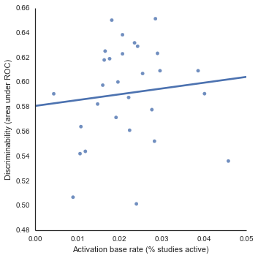
Figure 3. There is no significant relationship between the base rate of activation and discriminability of regions. Base rate is calculated by averaging the proportion of studies active for all voxels within a region.
Given that discriminability is not driven by regions’ anatomical properties (size), or other measures of activation dynamics, we analyzed how discriminability relates to the information content of neuroimaging studies. Regions varied in which topics were predictive of their activation (Figure 4). Predictive topics were consistent with existing knowledge about function to anatomy mappings: for example, auditory cortex, a highly discriminable region, was best predicted by a topic was associated with the words ’speech, auditory, and sounds’. Likewise, bilateral amygdala, a moderately discriminable region, was most predicted by a topic most associated with the word ‘emotional’. Surprisingly, regions with with low discriminability were also best predicted by topics consistent with their known cognitive function: for example, right middle frontal gyrus, was predicted by a topic about ‘inhibition, conflict, and control’, consistent with the role of lateral prefrontal cortex in cognitive control.
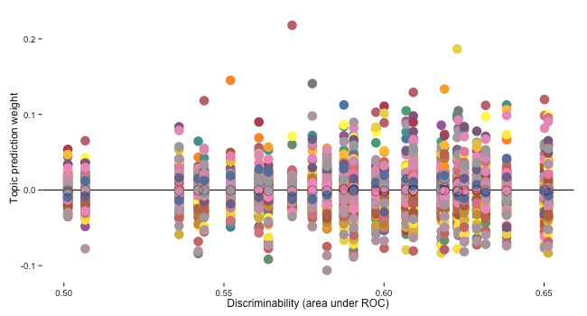
Figure 4. Topic prediction weights for each region ordered by discriminability. Regions on the right of the plot were easier to discriminate. Every dot represents the weight of a topic in discrimination. Positive values indicate the presence of that topic in a study predicts activity in that region, while negative values indicate that topic is anti-predictive of activity in that region.
While most regions were best predicted by cognitively sensible topics, more discriminable regions were more strongly related to these topics. Discriminability did not correlate with magnitude of topic weights (r = -0.08, p > 0.5), but did correlate with the absolute magnitude of the weights (r = 0.93, p < 0.001), suggesting discriminable regions are predicted by in both positive and negative directions by features of the studies. For example, an anterior insula / anterior cingulate cortex cluster – a highly discriminable region – is strongly predicted by a topic about ‘control, inhibition and conflict’ and anti-predicted by a topic about ‘motor and movement’.

Regions also varied in how many topics were necessary to discriminate their activation. We re-estimated discriminability for each region using only using the most predictive topic, and progressively added topics ordered by their weight in the full model to estimate how much predictive value additional features contribute. On average, using only the best topic for each region, discriminability was well below maximum performance (Figure 5a; roc-auc: 0.52). Additional topics improved discriminability, with each extra topic contributing less than the previous one. Near maximum discriminability (within 10% of maximum), was reached on average using 19.9 features, suggesting most regions show a diverse range of function. Regions also varied in the number of features necessary to achieve near maximum discriminability: for example, for a cluster including posterior and anterior cingulate many features were required to achieve maximum performance (Figure 4, left panel), whereas for right inferior frontal gyrus, performance close to the maximum was reached with only 15 features (Figure 4, right panel).
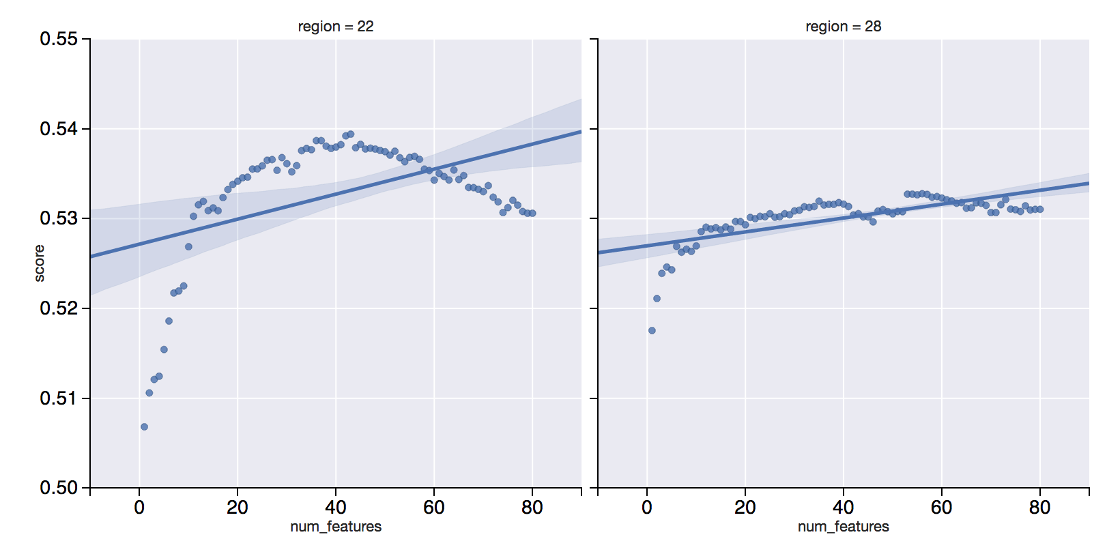
Figure 3. Discriminability for two regions, anterior/posterior cingular (left) and right inferior frontal gyrus (right), as a function of the number of features in the model. Features were added to the model progressively ordered by their topic weight in the full model, such that most useful features were added first. The region on the left required near 40 topics to reach maximum performance, while the region reached near maximum performance with only 15 topics.

References
Anderson M, Kinnison J, Pessoa L (2013). Describing functional diversity of brain regions and brain networks. 73: 50-8.
Chang L, Yarkoni T, Khaw M, Sanfey A (2013). Decoding the role of the insula in human cognition: functional parcellation and large-scale reverse inference. 23: 739-49.
Poldrack R, Mumford J, Schonberg T, Kalar D, Barman B. (2012) Discovering relations between mind, brain, and mental disorders using topic mapping. 8: e1002707.
Yarkoni T, Poldrack R, Nichols T, Van ED, Wager T (2011) Large-scale automated synthesis of human functional neuroimaging data. 8: 665-70.

